Cisco Firewall Rule Case Study
- Case Learning Objectives
- Explain why it is important to configure firewall effectively
- Create Cisco firewall rules to satisfy organization policies.
- Update firewall rules when network architecture is changed.
- Distinguish the different roles of external firewall and internal firewall.

- Case Description
You are the network administrator and it is your duty to configure the firewall rules to protect the company’s network. Figure 1 shows the architecture of your company network and the IP addresses of the computers. Table 1 shows the port numbers that are helpful in writing your firewall rules. Refer to the [1] for the formatting of Cisco Firewall Rules. Answer the following discussion questions (the mapping to the Bloom’s Taxonomy is listed below).

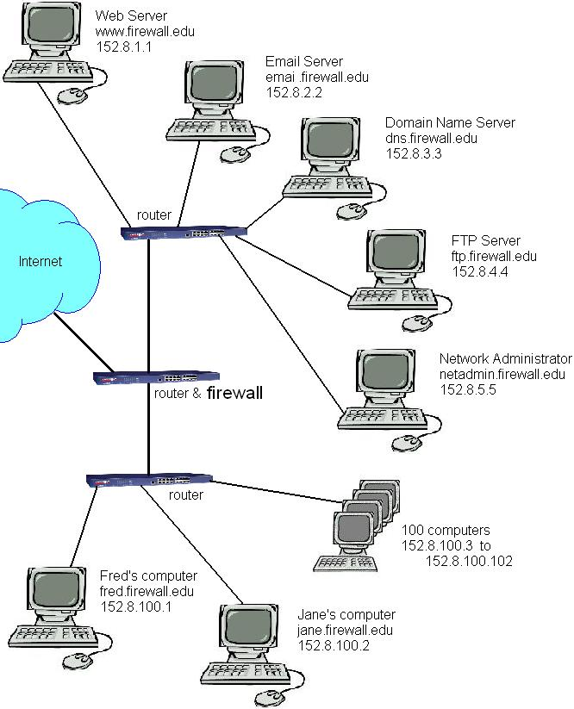
Figure 1: IP Addresses of each machine

Table 1. Port Numbers
Port | Service
21 | FTP
23 | Telnet
25 | Simple Mail Transport Protocol
53 | Domain Name Servers
69 | Trivial FTP
80 | HTTP
110 | POP3 client email
123 | Network Time Protocol
137-139 | Microsoft NETBIOS
143 | IMAP4 client email
161 | Simple Network Maintenance Protocol
443 | HTTPS
445 | Windows File Sharing
1863 | MSN Instant messaging
1214 | Kazaa
3389 | Windows Remote Desktop Protocol
5190 | AOL instant messenger
28800-29100 | MSN Gaming Zone
49876 | Firewall Simulation

- Discussion Questions and Their Mappings to Bloom’s Taxonomy

Table 1: Mapping of Cisco Firewall Rule case discussion questions to Bloom’s Taxonomy.
Cisco Firewall Rule Case Description Questions | Cognitive Levels
- Write the Cisco-like firewall rules to satisfy the following policy:  - Allow access to the homepage of your company.  - Allow the DNS to be accessed.  - Allow anyone to send email to the employee’s company account.  - Allow employees to access their company email account via POP.  - Allow the FTP server to be accessed.  - Disallow anyone to access your SNMP data.  - Disallow employees to access www.wasteoftime.com  - Allow anyone to send an AOL instant message to an employee in the company.  - Allow anyone to send an MSN instant message to an employee in the company.  - Prohibit Kazaa on all computers.  - Allow the CEO of the company to access the private Microsoft file share of the network administrator.  - Disallow others in the company to access the private Microsoft file share of the network administrator.  - Allow someone at 222.111.000.44 to do a Microsoft remote desktop connection to Jane’s computer. | Level 3: Application
2. Suppose your company decides to create a backup DNS using the FTP server. Update your firewall rules. | Level 3: Application
3. What changes would be necessary if the main router did not function as a firewall but the two other routers performed the firewall responsibilities? | Level 4: Analysis
4. How would the firewall capabilities change if the firewall was a separate box that came between the routers and the Internet? | Level 4: Analysis
5. Suppose the network architecture is changed to be as Figure 2. Reconfigure the firewall rules for both firewalls. | Level 3: Application  Level 4: Analysis
6. Explain why it is important to configure firewall effectively | Level 2: Comprehension
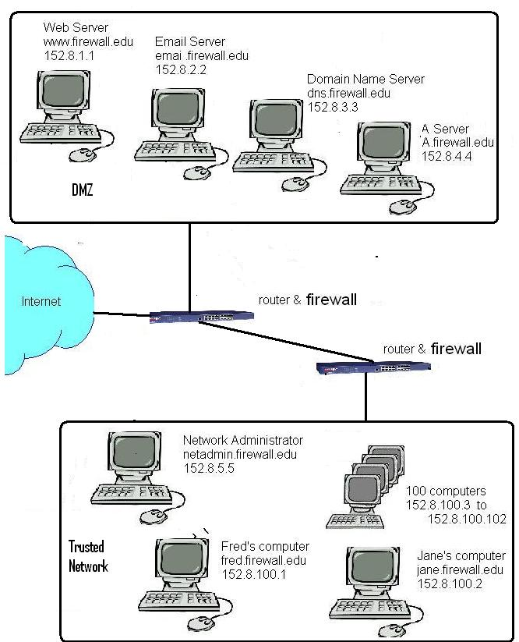
Figure 2: The changed network architecture

- References

[1] Tutorial on Cisco Firewall Rule Format (Included in the directory)

This case study is based on the Firewall Simulation Game developed by Dr. Williams at North Carolina A&T State University. The game can be accessed at: http://williams.comp.ncat.edu/FireSim/index.htm

